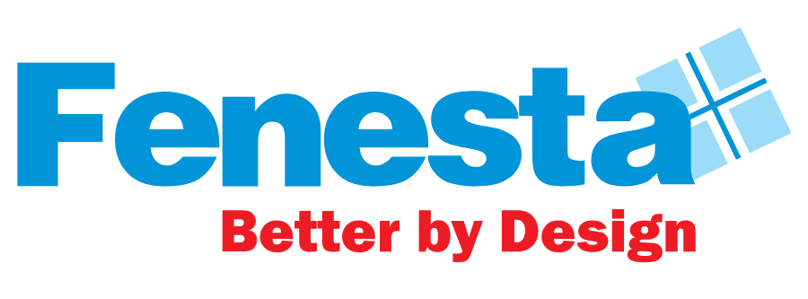
Press Release
Fenesta achieves INR 1000 Crores Order booking in FY24

National, 10th April, 2024: Fenesta, India's No.1 Windows and Doors Brand and a prominent name in the Indian fenestration industry, has achieved a major milestone of achieving Order booking of INR 1000 crores in FY24 across its multiple segments, which includes UPVC and aluminium windows and doors, solid panel doors and facades.
In the process, Fenesta has also surpassed the INR 200 crore mark in the order booking of aluminium windows and doors category. Fenesta's tireless expansion endeavors have led to the brand serving customers in over 900 cities, solidifying its nationwide footprint and bolstering market penetration across India. The company boasts of a robust sales and service network which includes 20 sales offices, 8 factories, 9 Signature Studios, 340 Channel Partners, as well as a strong direct sales force. The extensive network of showrooms and service touch points across India helped the company gain a wider customer reach, completing 4 Million installations. Notably, Fenesta also has an International presence in Maldives, Nepal and Bhutan.
Commenting on this milestone, Saket Jain, Business Head – Fenesta Building Systems, stated, "Fenesta has experienced consistent growth since its inception, and over the past decade, our momentum has only intensified. Achieving a milestone of 1000 Cr. order booking is significant, showcasing our robust market presence and increasing consumer trust. We're committed to further growth through expanding our service network, innovating our product lineup, and maintaining service excellence for our customers."
With an unwavering commitment to quality, innovation, and customer service across all fronts, Fenesta is ready to venture into the next chapter of its journey. Fenesta aims to lead positive change and establish new standards in the fenestration industry.
About Fenesta Building Systems
Fenesta is India’s largest windows and doors brand and a part of the Rs. 12,080 Cr conglomerate DCM Shriram Ltd. Its installations across more than 4,00,000 homes have already crossed the magical 4 million mark. Empowered with the knowledge of India’s extreme conditions, Fenesta has designed uPVC windows and doors that can also withstand India’s extreme climate. After uPVC, Fenesta took another technological leap when it introduced its ultra-luxury Aluminium Windows and Doors and Solid Panel Doors and Facades. With a dynamic direct sales force, Fenesta has successfully expanded its reach internationally, penetrating markets in the Maldives, Nepal and Bhutan. Fenesta offers a complete customized end-to-end solution: survey, design, manufacture, delivery, installation and service to all its customers. The entire process is synchronized with the pace of each project. As a leader in the category, Fenesta takes pride in its ability to serve individual homes and large developers with equal ease.

